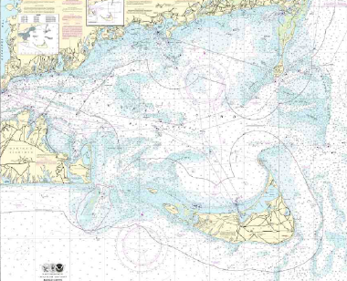
Nantucket Inshore Classic
2020 Boundaries

Boundary Description:

- Southern Boundary - 3 Mile Limit Line
- Western Boundary - Muskeget Channel Buoy “Hooter” to Yellow Flashing Light (South side Marthas Vineyard) North to Nobska Light House.
- Northern Boundary - Shoreline of Cape Cod and Monomoy Islands to Buoy “C” (East of Chatham)
- Eastern Boundary - Buoy “C” to Pollock Rip Channel Buoy “4” to Great Pt. Green Buoy “1” then 3 Mile Limit Line to southern boundary

